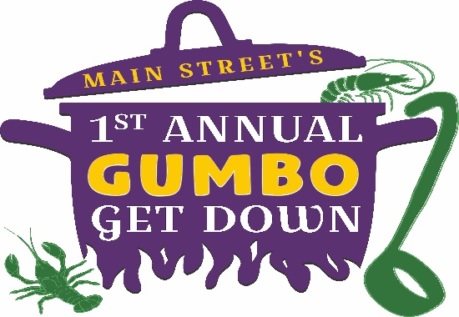

Cook-Off Guidelines

- Cooks are to prepare and cook in a sanitary manner. Cooking conditions are subject to inspection by the judging committee. Identified by the committee shall be immediately corrected or the team shall be disqualified.

- Teams are allowed to bring one generator per team, electricity is not provided

- Teams must provide a fire extinguisher.

- No glass containers are allowed. Metal, Plastic and Paper ONLY.

- Teams are asked to prepare at least 4 Gallons of Gumbo.

- Gumbo must be prepared from scratch including roux (NO Commercial Gumbo Mixes) and all ingredients must be added on site and in raw form (except meat cooked with stock) but may be chopped and cut ahead of time. No ingredients can be combined offsite, we want all the cooking to be done at the event to keep it fair. Teams will be allowed to bring all ingredients prepped in advance (chopped veggies, stock and cooked meat if desired). However, ALL TEAMS must combine ALL ingredients on site and provide rice or other ingredients.

- Team Captain: Each team will designate a team captain, who is responsible for seeing that each assigned area is kept clean, that a judging sample is taken to the judging table and that all team members have read and understood these rules and regulations.

- Space: Each Team will be provided a 10’ x 10’ tent and 2 tables. ALL teams must bring all supplies necessary for cooking. Main Street will not be responsible for supplying utensils, pots, pans, burners, etc. Please ensure your area is clean and all trash has been placed in the proper containers before leaving your site.

- Supplied items: Main Street will provide sampling cups, spoons, napkins and judge’s sampling cups.

- Judging: Containers for the judges will be provided the morning of the cook-off. The team captain is required to deliver the sample cups to the judging area at a set time. (This information will be communicated on the day of.) All gumbo will be judged in the same category regardless of the preparation method. The winners of the cook-off will be announced at approximately 3:30 pm. All decisions by the judges is final. Cooking conditions are subject to inspection. Failure to follow these rules will be grounds for disqualification. Any changes to these official rules and regulations will be communicated to teams in advance of the event.

- Judges will judge on the following categories: Appearance, Aroma, Flavor, Consistency and Texture.

- Main Street reserves the right to make additional regulations as situations warrant. Decisions of Main Street and Judges are final.

